Histograms

Teacher Background Information for Introducing Histograms to Students
The following lessons and worksheets were designed to provide a basic format when introducing the concept of data collection and histograms (bar graphs of frequency) to students. The following are explanations to the lessons.

Basic Knowledge of Histograms
- Histogram Worksheet
This worksheet is designed to introduce the students to Histograms. It can be used at any time but may serve as a good spring board as to what a histogram is and how it is useful in data analysis.

- Histograms and Distribution (hands on)
This activity is designed as a hands-on demonstration of how ‘random’ distributions of paper punch-outs fall on a grid. Questions are posed to the student at the end of the activity and a teacher answer sheet is included to help facilitate the discussion.
Note: The activity is designed to be done in the classroom; however, a variation can be done outside on a football field with students throwing balls from each end zone toward center field

- Histograms Lesson 1
This lesson takes ‘canned data’ from rolling a ball down a ramp and has the students determine groupings (bins), sorting the data into the bins and graphing by hand the results of the sorting. Questions are posed to the student at the end of the activity and a teacher answer sheet is included to help facilitate the discussion.

More Advanced Knowledge
- Histogram Lesson 2 (pre Question of Timing worksheet)
This lesson is a reinforcement for Lesson 1 but now uses actual muon detector TOFs (time of flights) for the set of data and introduces the students to the nanosecond. The students must determine how they are going to bin the data and graph the results by hand. Because the data is already sorted in ascending order, they should easily recognize the trend of 0.75 intervals in the time values. Also the concept of ‘erroneous’/outlying data is introduced to the student. Questions are posed to the student at the end of the activity and a teacher answer sheet is included to help facilitate the discussion.

Histogram Worksheet

The 3 histograms below show the batting averages of the winners of the batting title in the major league baseball (for both the American & National leagues) for certain years in the 1900s. Batting average shows the percent (written as a decimal) of the time a certain player gets a hit. A player who has a batting average of 0.405 has gotten a hit in 40.5 % of the times that they were at bat. The batting title is an award given to the player with the highest batting average for a given season. Refer to the histograms as you answer questions 1 – 6.

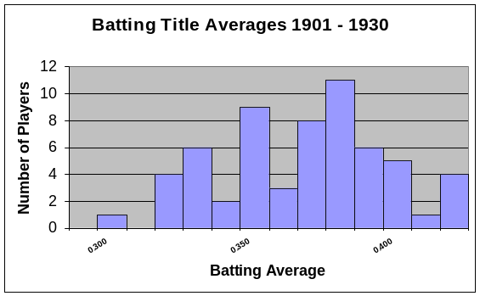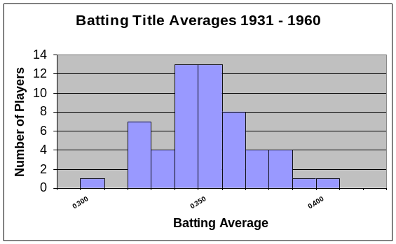

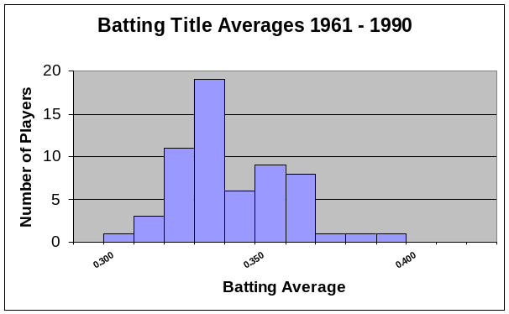

_________1. How many batting titles were won with a batting average of between 0.300 and 0.350 from 1901 to 1930?

_________2. How many batting titles were won with a batting average of between 0.300 and 0.350 from 1931 to 1960?

_________3. How many batting titles were won with a batting average of between 0.300 and 0.350 from 1961 to 1990?

4. If you were to find the mean of each of the winning batting averages for each time period, which time period do you think would have the highest mean? Explain.
____________________________________________________________________________________________________________________________________________________________________

5. As the century progressed, what in general happened to the batting averages of the batting title winners? Explain.
____________________________________________________________________________________________________________________________________________________________________
____________________________________________________________________________________________________________________________________________________________________

For questions 6 – 10, refer to the following 2 histograms. These histograms were made in an attempt to determine if William Shakespeare was really just a pen name for Sir Francis Bacon. (A pen name is a fake name used by another person when writing). A few scholars have had this idea and in order to determine if this was true, a researcher had to count the letters in every word of Shakespeare’s plays & Bacon’s writing (and you thought you had a lot of homework). Their results are recorded in the histograms below.

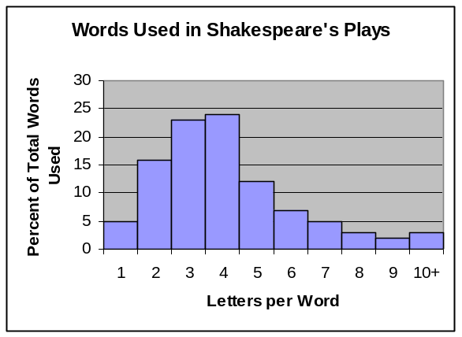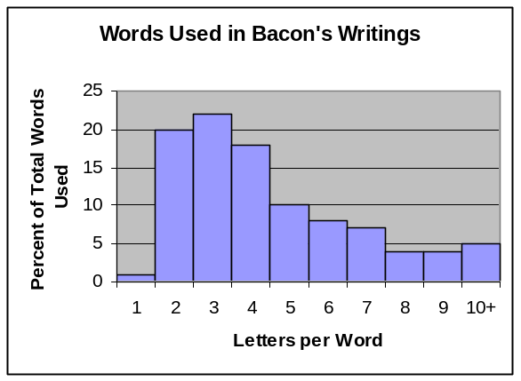

_________6. What percent of all Shakespeare’s words are 4 letters long?

_________7. What percent of all Bacon’s words are 4 letters long?

_________8. What percent of all Shakespeare’s words are more than 5 letters long?

_________9. What percent of all Bacon’s words are more than 5 letters long?

10. Based on these histograms, do you think that William Shakespeare was really just a pen name for Sir Francis Bacon? Explain.
_____________________________________________________________________________________________________________________________________________________________________________________________________________________

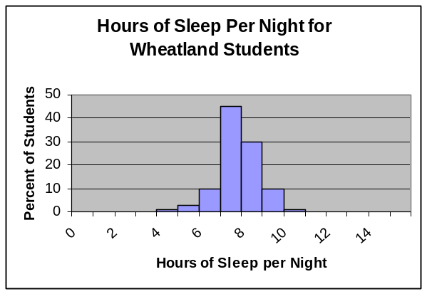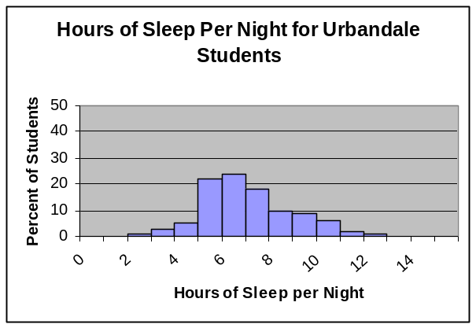

Suppose that the two histograms above show the sleeping habits of the teens at two different high schools. Wheatland High School is a small rural school consisting of 100 students while Urbandale High School is located in a large city and has 3,500 students.

_________11. About what percent of the students at Wheatland get at least 8 hours of sleep per night?

_________12. About what percent of the students at Urbandale get at least 8 hours of sleep per night?

_________13. Which high school has more actual students that sleep between 9 – 10 hours per night?

_________14. Which high school has a higher median sleep time?

15. Wheatland’s percent of students who sleep between 8-9 hours a night is ________ % more than Urbandale’s percent of students who sleep between 8-9 hours per night.

16. Consider the type of data in the last two sets of problems (letters per word & sleep times).

_________a) Are letters per word qualitative or quantitative?

_________b) Are sleep times qualitative or quantitative?

_________c) Which data set is continuous?

_________d) Which data set is discrete

- The charts below shows the age of the actress & actor who won the Oscar for best actress or actor during the first 30 years of the Academy Awards. Use the charts to make two histograms (one for winning actresses ages & one for winning actors ages) displaying this information. Use bin widths of ten years (0-9; 10-19; 20-29 etc.)

Year | Age of Winning Actress | Age of Winning Actor
1928 | 22 | 42
1929 | 36 | 40
1930 | 28 | 62
1931 | 62 | 53
1932 | 32 | 35
1933 | 24 | 34
1934 | 29 | 33
1935 | 27 | 52
1936 | 27 | 41
1937 | 28 | 37
1938 | 30 | 38
1939 | 26 | 34
1940 | 29 | 32
1941 | 24 | 40
1942 | 34 | 43
Year | Age of Winning Actress | Age of Winning Actor
1943 | 24 | 49
1944 | 29 | 41
1945 | 37 | 40
1946 | 30 | 49
1947 | 34 | 56
1948 | 34 | 41
1949 | 33 | 38
1950 | 28 | 38
1951 | 38 | 52
1952 | 45 | 51
1953 | 24 | 35
1954 | 26 | 30
1955 | 47 | 38
1956 | 41 | 41
1957 | 27 | 43

18. Write a short paragraph discussing what your two histograms reveal.

______________________________________________________________________________________________________________________________________________________________________________________________________________________________________________________________________________________________________________________________________________________________________________________________________________________________________________________________________________________________________________________________________________________________________________________________

Histograms and Distribution Activity

Materials:
- Football field pre-copied onto a large piece of paper.
- Handful of paper disks from a 3-hole punch apparatus
- Graph paper (or access to a computer) to make the histogram

(-) |  |  |  |  |  |  |  |  |  |  | (+)
E |  |  |  |  |  |  |  |  |  |  | E
N |  |  |  |  |  |  |  |  |  |  | N
D |  |  |  |  |  |  |  |  |  |  | D
 | -(0-10) | -(10-20) | -(21-30) | -(31-40) | -(41-50) | 50-41 | 40 - 31 | 30 - 21 | 20 - 11 | 10 - 0
Z |  |  |  |  |  |  |  |  |  |  | Z
O -55 | -45 | -35 | -25 | -15 | -5 | 5 | 15 | 25 | 35 | 45 | To O
N |  |  |  |  |  |  |  |  |  |  | N
E |  |  |  |  |  |  |  |  |  |  | E

Pre-Activity questions:
- When you drop the paper disk, if it falls on the line between 2 zones, how will you decide which zone to count it in? _____________________________________________________
_______________________________________________________________________________________________________________________________________________________
- Why are the zone values on the left recorded as negative? ____________________________
___________________________________________________________________________
___________________________________________________________________________
- When you create the histogram of your data, what values will you place on the
x-axis? _________________________On the y-axis?______________________

Procedure:
- Take a handful of paper punch-outs; hold them approximately 40 cm above the middle of the field. Have a partner check to see that you are not skewed toward either side of the 50 yard line.
- Drop the paper punch-outs onto the field.
- Create a chart to record the data for the number of paper pieces that fell into each zone. Record each zone using the bottom set of numbers. This represents the average distance from the center, 50 yard line.
- From your chart, graph the data as a histogram.
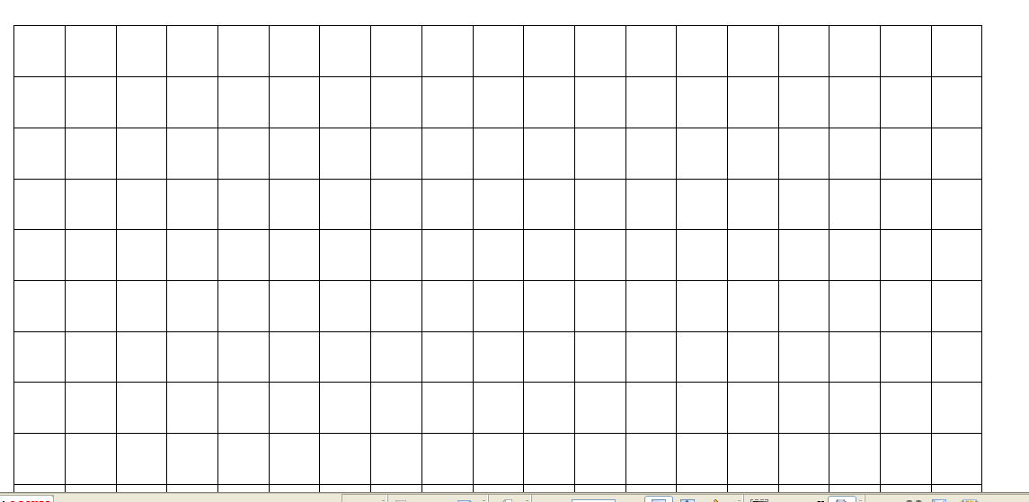

Analysis questions
- Draw the general shape of your histogram as a line graph:

- Does the line graph have a characteristic shape? _________
- If so, what is the general shape of this graph?___________________________________________
- Explain why you think the graph is shaped this way: _____________________________
________________________________________________________________________
________________________________________________________________________

- Were there any ‘outlying’ values on your graph (beyond the general graph pattern or off the field)? _____________ If so, explain if these data points should be discarded: ____________________________________________________________________________________________________________________________________________________________________________________________________________________________________

- Brainstorm some ideas as to why some of the paper disks fell so much farther from the 50 yard line then others:
  - ____________________________________________________________
  - ____________________________________________________________
  - ____________________________________________________________
  - ____________________________________________________________
  - ____________________________________________________________

- How would the following scenarios affect the results of your histogram:
Height of the drop - ____________________________________________
_____________________________________________________________
_____________________________________________________________

Location of the drop in reference to the 50 yard line - __________________
_____________________________________________________________
_____________________________________________________________

Throwing the disks onto the field instead of dropping them - _____________
______________________________________________________________
______________________________________________________________

- How can viewing a histogram be used to reconstruct the ‘history’ of the event that occurred?
______________________________________________________________
______________________________________________________________
______________________________________________________________

Teacher answer sheet
Pre-Activity answers
- The ‘bins’ representing the grouping of the yard lines on the field is on the x-axis and the ‘frequency’ or ‘number of events’ is on the y-axis
- The zones to the left of the 50 yard line are negative because of the need to address the directionality based on the location of the areas to right and left of the 50 yard line. The left was arbitrarily determined to be the negative values.
- The graph should have the look of a Gaussian, bell-shaped curve.

- The outlying data points are erroneous and can be deleted from analysis because they are outlying values.
- and 4. There are several reasons why some of the paper disks fell so far from the 50 yard line and this makes for good discussion. Possibilities include - air current, incomplete disk size, location in the hand, random effect….The affects of the height, location and throwing create histograms that may have larger bins or bins that are shifted to the right or to the left.
5. A histogram shows the possible origin, velocity, implications of how the event occurred.

Sample Data

paper drop
0
20
40
60
80
100
120
-55
-45
-35
-25
-15
-5
5
15
25
35
45
55
Average dist from 50 yard line
# paper disks
Series1
 | # paper disks | midpoint of event location | total number
 | 3 | -55 | -165
 | 6 | -45 | -270
 | 13 | -35 | -455
 | 19 | -25 | -475
 | 38 | -15 | -570
 | 96 | -5 | -480
 | 82 | 5 | 410
 | 33 | 15 | 495
 | 16 | 25 | 400
 | 7 | 35 | 245
 | 8 | 45 | 360
 | 1 | 55 | 55
Total disks | 322
avg distance from 50 |  |  | -1.40

Note: average distance from 50 is determined by adding up the total number columns and dividing that value by the total disks (322). This average distance value gives you the ‘skew’ of the data from the center point.

Histograms – Lesson 1
While performing a routine experiment, students gathered data for the time required for a ball to roll down a 1 meter ramp at a 30 degree angle. The following data was collected:
trial | time (sec) |  | time range (sec) | # of values
1 | 0.316
2 | 0.324
3 | 0.325
4 | 0.316
5 | 0.309
6 | 0.316
7 | 0.311
8 | 0.312
9 | 0.317
10 | 0.308
11 | 0.311
12 | 0.399
13 | 0.313
14 | 0.314
15 | 0.314
16 | 0.242
17 | 0.321
18 | 0.316
19 | 0.309
20 | 0.317

- To determine the range of values for the chart determine the highest and lowest values for time. Highest ________________Lowest_________________
- Take the difference in the highest and lowest values and divide the difference into ___________ ranges (known as bins)
- Use the data to complete the chart to the right, categorizing each time value into its proper range.
- On the graph paper, label the x-axis as time (seconds) and the y-axis as frequency.
- For each time range shade in the number of boxes (frequency) that correspond to the number of events that occurred within that range.

Analysis questions
- What do you notice about the graphed results of the histogram?

- Note the outlying data points. Are these valid points or should they be disregarded? Why or why not?

3. What is binning?

4. What is on the y-axis of any histogram graph?

5. What is a histogram?

6. How is a histogram used to determine valid/invalid data?

7. Based on the histogram, what is the time for the ball to roll down the ramp?

8. Based on the histogram, what is the reasonable range of uncertainty in the time?

Teacher answer sheet - Histograms – Lesson 1
- The data is grouped so that the most frequent values are a distinguishing peak on the graph.
- The outlying data points are erroneous and can be deleted from the analysis of the the values.
- Binning is a method of sorting data by clustering similar values and determining frequency.
- The ‘frequency’ or ‘number of events’ is on the y-axis.
- A histogram is a bar graph that shows how often events occurs within a bin/range.
- A histogram is used to determine valid data by looking at the bulk of where the data falls and identifying any outlying data that is can be removed.
trial | time (sec) |  | time range (sec) | # of values
1 | 0.316 |  | 0.240 - 0.248 | 1
2 | 0.324 |  | 0.249 - 0.257
3 | 0.325 |  | 0.258 - 0.266
4 | 0.316 |  | 0.267 - 0.275
5 | 0.309 |  | 0.276 - 0.284
6 | 0.316 |  | 0.285 - 0.293
7 | 0.311 |  | 0.294 - 0.302
8 | 0.312 |  | 0.303 - 0.311 | 5
9 | 0.317 |  | 0.312 - 0.320 | 10
10 | 0.308 |  | 0.321 - 0.329 | 3
11 | 0.311 |  | 0.330 - 0.328
12 | 0.399 |  | 0.339 - 0.347
13 | 0.313 |  | 0.348 - 0.356
14 | 0.314 |  | 0.357 - 0.365
15 | 0.314 |  | 0.366 - 0.374
16 | 0.242 |  | 0.375 - 0.383
17 | 0.321 |  | 0.384 - 0.392
18 | 0.316 |  | 0.393 - 0.401 | 1
19 | 0.309
20 | 0.317 |  | 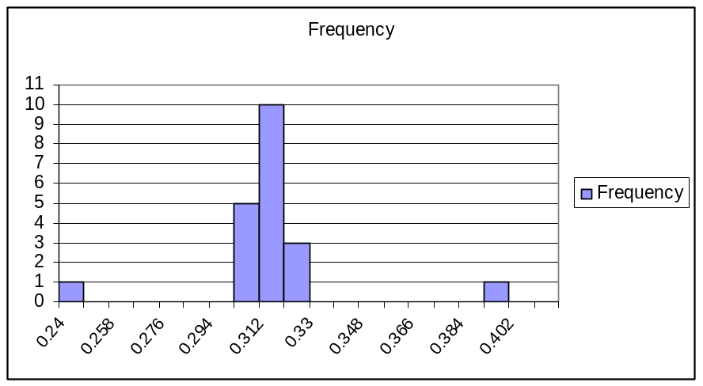
Bin | Frequency
0.24 | 1
0.249 | 0
0.258 | 0
0.267 | 0
0.276 | 0
0.285 | 0
0.294 | 0
0.303 | 5
0.312 | 10
0.321 | 3
0.33 | 0
0.339 | 0
0.348 | 0
0.357 | 0
0.366 | 0
0.375 | 0
0.384 | 0
0.393 | 1
0.402 | 0

Histograms – Lesson 2 Name ________________________
While performing a routine experiment, students gathered data for the time required for a muon to strike 2 detectors. The following data was collected and sorted:
Muon Speed Mode on: from channel 1 to 2 (dist 1.41m) |  |  |  | Time (ns)
1 |  | (1,2,-,-) | TOF | -8.25
2 |  | (1,2,-,-) | TOF | 0
3 |  | (1,2,-,-) | TOF | 1.5
4 |  | (1,2,-,-) | TOF | 1.5
5 |  | (1,2,-,-) | TOF | 1.5
6 |  | (1,2,-,-) | TOF | 1.5
7 |  | (1,2,-,-) | TOF | 2.25
8 |  | (1,2,-,-) | TOF | 2.25
9 |  | (1,2,-,-) | TOF | 2.25
10 |  | (1,2,-,-) | TOF | 3
11 |  | (1,2,-,-) | TOF | 3
12 |  | (1,2,-,-) | TOF | 3
13 |  | (1,2,-,-) | TOF | 3
14 |  | (1,2,-,-) | TOF | 3
15 |  | (1,2,-,-) | TOF | 3
16 |  | (1,2,-,-) | TOF | 3.75
17 |  | (1,2,-,-) | TOF | 3.75
18 |  | (1,2,-,-) | TOF | 3.75
19 |  | (1,2,-,-) | TOF | 3.75
20 |  | (1,2,-,-) | TOF | 3.75
21 |  | (1,2,-,-) | TOF | 4.5
22 |  | (1,2,-,-) | TOF | 4.5
23 |  | (1,2,-,-) | TOF | 4.5
24 |  | (1,2,-,-) | TOF | 4.5
25 |  | (-,2,-,-) | TOF | 4.5
26 |  | (1,2,-,-) | TOF | 4.5
27 |  | (1,2,-,-) | TOF | 4.5
28 |  | (1,2,-,-) | TOF | 5.25
29 |  | (1,2,-,-) | TOF | 5.25
30 |  | (1,2,-,-) | TOF | 5.25
31 |  | (1,2,-,-) | TOF | 5.25
32 |  | (1,2,-,-) | TOF | 5.25
33 |  | (1,2,-,-) | TOF | 5.25
34 |  | (1,2,-,-) | TOF | 5.25
35 |  | (1,2,-,-) | TOF | 6
36 |  | (1,2,-,-) | TOF | 6
37 |  | (1,2,-,-) | TOF | 6
38 |  | (1,2,-,-) | TOF | 6.75
39 |  | (1,2,-,-) | TOF | 7.5
40 |  | (1,2,-,-) | TOF | 8.25
Time range (nanoseconds) | # of values

- Do you see a pattern in the time data as it was recorded off of the detectors? What is it?

- Are there any values that appear to be ‘outlying’ data that can be removed prior to doing the histogram? Why would you exclude them?

- Now that the outlying numbers have been removed, determine the range of values, highest and lowest values for time in nanoseconds Highest _____________________ Lowest______________________
- Determine the bin ranges that will be used and complete the chart to the right, categorizing each time value into its proper range.
- On the graph paper, label the x-axis as time (seconds) and the y-axis as frequency.
- For each time range shade in the number of boxes (frequency) that correspond to the number of events that occurred within that range.
Teacher Answer Sheet - Histograms – Lesson 2
- The pattern of the recorded time data has 0.75 differences between recordings. This is due to the internal mechanism (resolution) of the boards to record in that time interval
- The outlying values of -8.25 and 8.25 could be removed prior to doing the histogram but it is important that the students know that the -8.25 is not being removed because it is negative… this leads to a good discussion of why negative numbers might appear and that it doesn’t necessarily mean that they need to be removed. The reason that these two values are removed is due to the fact that they are so far out of the range of the other values that they are probably due to some error.
Bin | 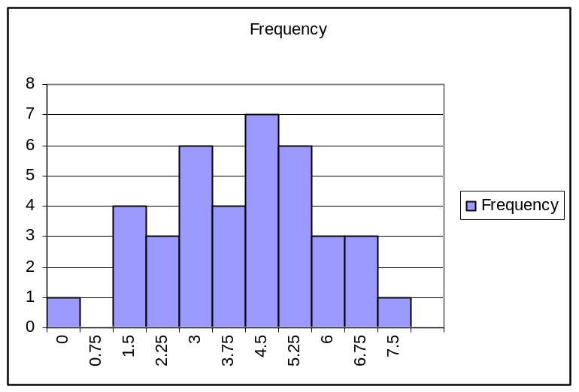  Frequency
0 | 1
0.75 | 0
1.5 | 4
2.25 | 3
3 | 6
3.75 | 4
4.5 | 7
5.25 | 6
6 | 3
6.75 | 3
7.5 | 1

